SIMATS ENGINEERING (SAVEETHA SCHOOL OF ENGINEERING)
Department of Computer Science and Engineering
CO1 ASSESSMENT TOOL 1 – CASE STUDY ANALYSIS
Course Code: CSA10 / CSA1005 | Course Title: Software Engineering
Problem Statement 27: Smart Renewable Energy Asset Management System

Student Name: | REVANTH B
Registration No.: | 192524289
Date: | 10-10-26
Duration: | 60 minutes
Total Marks / Weightage: | 25 Marks / 20%

1. Understand the Problem Statement

1.1 Explanation of the Problem
Renewable-energy installations such as solar panels, wind turbines, batteries and inverters are spread across many sites and need regular inspection and maintenance to deliver their rated output. In many organizations the information about these assets (specifications, performance readings, maintenance dates, faults and repairs) is scattered across spreadsheets, paper logs and separate vendor tools. Because there is no single source of truth, maintenance is mostly reactive, faults are noticed late, and managers cannot easily see which asset is underperforming or due for inspection.
The problem is therefore to design and develop a Smart Renewable Energy Asset Management System: a centralized platform that stores asset information, monitors performance indicators, records maintenance and fault activities, and automatically identifies assets that need inspection. It should also give asset-level dashboards and historical performance analysis so that decisions are based on data rather than guesswork.

1.2 Objectives of the Proposed System
- Maintain a complete, up-to-date inventory of renewable assets.
- Record asset specifications (type, capacity, make, model, installation date, location, warranty).
- Monitor asset performance indicators such as output, efficiency, temperature and battery state of charge.
- Track preventive and corrective maintenance schedules.
- Record faults and repairs with cause, action taken, downtime and cost.
- Generate automatic maintenance alerts for due or overdue tasks and abnormal readings.
- Maintain a full maintenance and fault history for every asset.
- Analyze performance trends to predict degradation and plan inspections.
- Generate operational reports for management, auditors and regulators.

1.3 Scope of the Problem
In scope: asset registration and specification management; performance data collection and visualization; maintenance planning and work orders; fault and repair logging; alert generation; historical analysis and report generation; role-based access for different users; support for multiple sites and asset types (solar, wind, battery, inverter).
Out of scope: power-grid dispatch and energy trading, billing of electricity customers, physical control or remote switching of equipment, and procurement/ERP accounting. These can be integrated later through APIs.

2. Identify Key Stakeholders and Challenges

2.1 Stakeholders, Roles and Responsibilities
Stakeholder | Role and Responsibility | Main Interest in the System
Asset Owner / Organization Management | Takes strategic decisions on investment, upgrades and replacement; approves budgets. | Higher utilization, lower cost, regulatory compliance, ROI.
Operations / Plant Manager | Supervises daily operation of all sites; reviews dashboards and reports; assigns work. | Real-time visibility and fewer outages.
Maintenance Engineers / Technicians | Perform inspections, preventive maintenance and repairs; update work orders and fault records. | Clear schedules, alerts, easy mobile data entry.
System Administrator | Manages users, roles, configuration, backups and system security. | Secure, stable and easy-to-administer platform.
Data / Performance Analyst | Studies performance trends, efficiency losses and failure patterns. | Clean historical data and analytical reports.
Equipment Vendors / Service Contractors | Supply equipment, warranty service and specialized repairs. | Accurate fault and warranty records.
Regulators and Auditors | Check safety, environmental and reporting compliance. | Reliable, auditable operational reports.
Software Development Team | Analyze, design, build, test and maintain the platform. | Clear requirements and manageable scope.

2.2 Major Challenges and Issues Faced
- Scattered data: asset details, readings and maintenance logs sit in different files and tools, causing duplication and inconsistency.
- Reactive maintenance: faults are discovered only after output drops or equipment fails, leading to long downtime.
- Missed schedules: manual calendars cause overdue inspections and warranty violations.
- Remote and distributed sites: assets located in different places make physical monitoring costly and slow.
- Heterogeneous equipment: different vendors use different data formats and protocols.
- Weather dependency: output varies with sunlight and wind, so it is hard to separate normal variation from real faults.
- Poor history and traceability: repair records are incomplete, so repeat failures are not identified.
- Reporting effort: operational and compliance reports take days to prepare manually.

3. Analyze the Current Approach

3.1 Description of the Existing System
In the current process, each asset is recorded in spreadsheets or paper registers. Technicians visit sites on a fixed calendar, note readings by hand, and report faults by phone, e-mail or messaging apps. Some inverters and turbines have a vendor-specific monitoring screen, but these tools work in isolation and do not share data. Managers compile monthly reports by manually combining files from different sites.

3.2 Strengths and Limitations
Strengths | Limitations
Low initial cost and simple to start; no new software to learn. | No centralized data; duplication and inconsistent records.
Vendor tools give detailed data for their own equipment. | Tools are not integrated, so there is no combined view of all assets.
Experienced technicians use field knowledge effectively. | Knowledge stays with individuals and is lost when staff change.
Fixed inspection calendars give a basic maintenance routine. | Time-based, not condition-based; no automatic alerts.
Paper or spreadsheet records are easy to produce quickly. | Hard to search, analyze trends, or audit; high risk of data loss and human error.

3.3 Problems and Gaps to be Addressed
- Absence of a single, reliable asset database.
- No real-time or near-real-time performance monitoring and threshold-based alerting.
- No automated maintenance scheduling and tracking of work-order status.
- No structured fault and repair history to support root-cause analysis.
- No trend analysis or predictive indicators to prevent failures.
- No dashboards or one-click operational reports.
- Weak access control, backup and audit trail.

4. Propose a Suitable Solution Using Software Engineering Principles

4.1 Proposed Software-Based Solution
The proposed solution is a web-based, role-driven Smart Renewable Energy Asset Management System with a mobile-friendly interface for field staff. Asset data is stored in a central relational database, while sensor and inverter readings are collected through an integration layer (IoT gateway or vendor APIs) and kept in a time-series store. A service layer applies business rules to generate alerts and maintenance tasks, and a dashboard layer presents asset-level and fleet-level information. The overall layered architecture is shown in Figure 1.
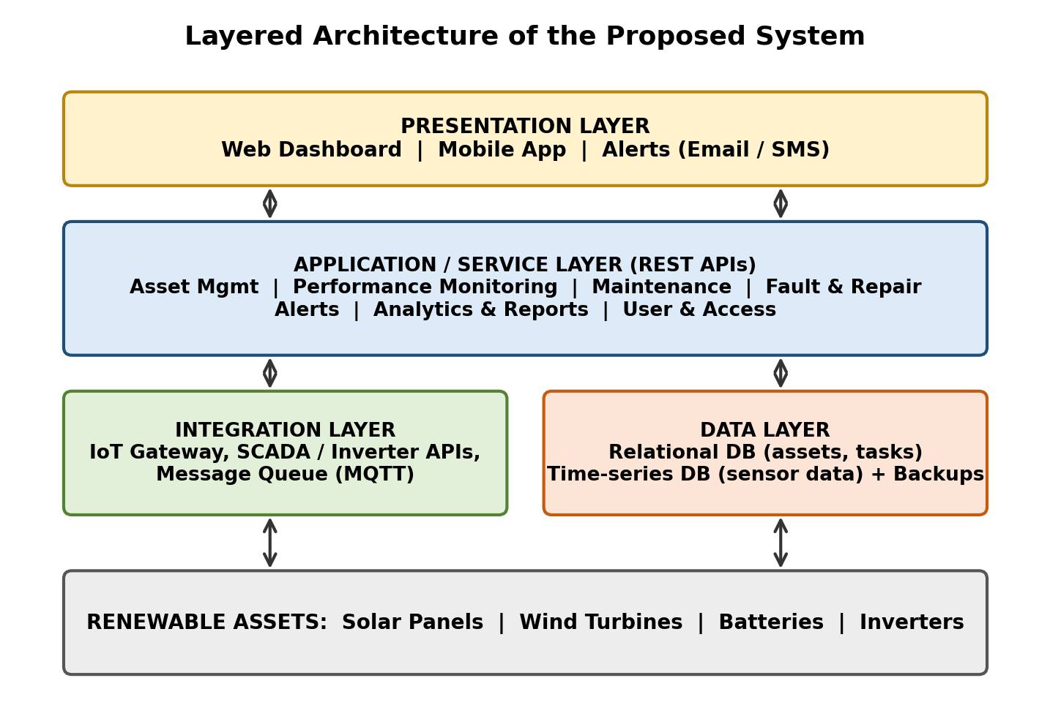
Figure 1: Layered architecture of the Smart Renewable Energy Asset Management System

4.2 Major Functional Modules
Module | Description
Asset Inventory & Specification | Registers solar panels, turbines, batteries and inverters with type, capacity, make, model, location, installation and warranty details.
Performance Monitoring | Collects indicators (power output, efficiency, voltage, temperature, state of charge) and compares them with expected values.
Maintenance Scheduler | Creates preventive schedules and work orders, assigns technicians and tracks completion.
Fault & Repair Management | Logs faults, severity, root cause, repair action, spare parts, downtime and cost.
Alert & Notification Engine | Sends e-mail/SMS/app alerts for due maintenance, threshold breaches and assets needing inspection.
Asset History Module | Maintains a complete timeline of performance, maintenance and faults per asset.
Analytics & Reporting | Dashboards, trend analysis, availability and downtime reports, exportable as PDF/Excel.
User & Access Management | Authentication, role-based authorization, audit logs and configuration.
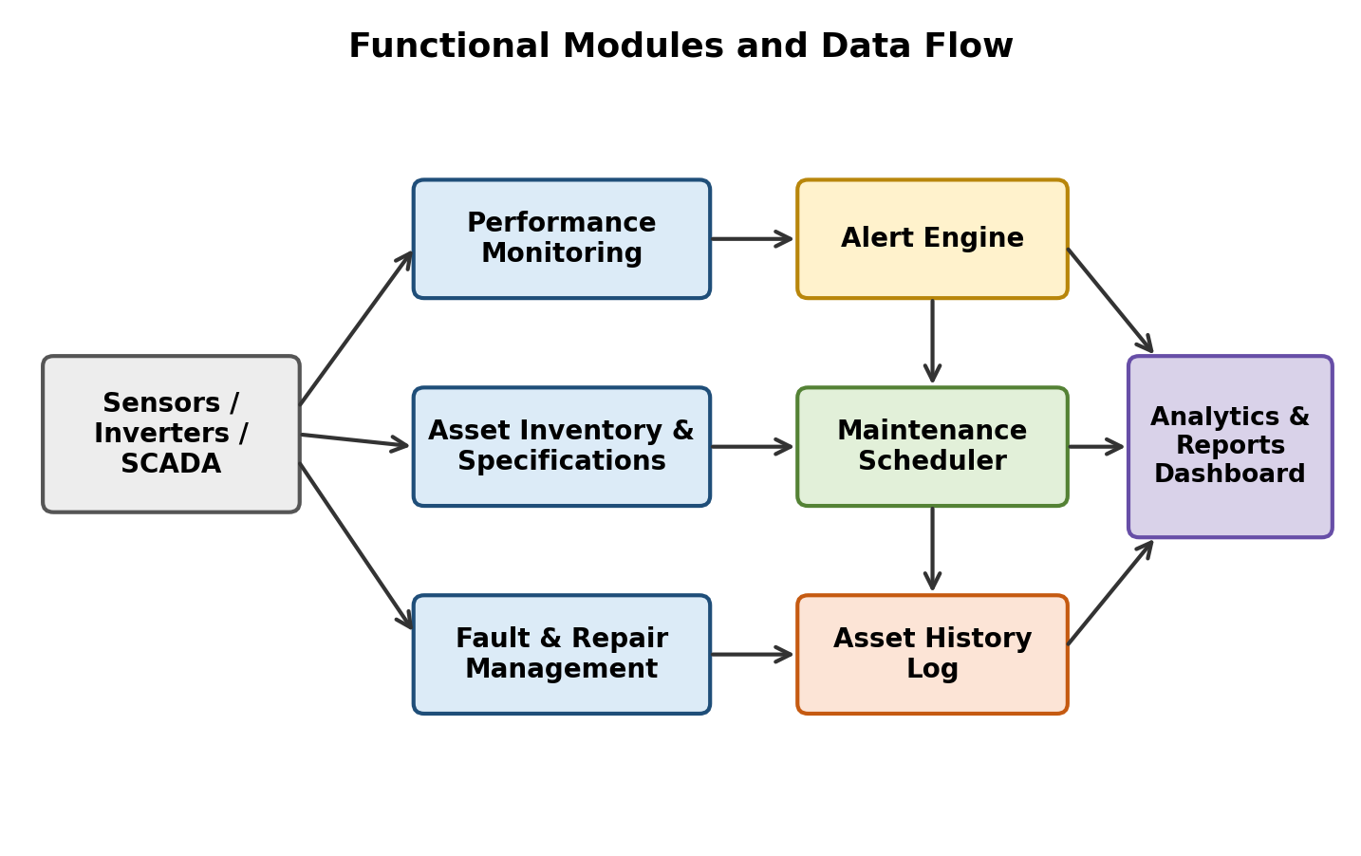
Figure 2: Functional modules and data flow

4.3 Functional Requirements
- FR1: The system shall allow authorized users to add, update, view and deactivate assets and their specifications.
- FR2: The system shall ingest and store performance readings for each asset at configurable intervals.
- FR3: The system shall display asset-level dashboards and historical performance graphs.
- FR4: The system shall schedule preventive maintenance and create work orders automatically.
- FR5: The system shall record faults, repairs, parts used, downtime and cost.
- FR6: The system shall generate alerts for due/overdue maintenance and abnormal performance.
- FR7: The system shall maintain maintenance and fault history for every asset.
- FR8: The system shall analyze performance trends and flag assets requiring inspection.
- FR9: The system shall generate operational reports and export them in PDF and Excel formats.
- FR10: The system shall provide role-based login for admin, manager, engineer, analyst and auditor.

4.4 Non-Functional Requirements
Attribute | Requirement
Performance | Dashboards load within 3 seconds; supports data from at least 10,000 assets/sensors.
Scalability | Horizontal scaling; new sites and asset types added without redesign.
Reliability / Availability | 99.5% uptime; no data loss with automated backups and buffering of sensor data during network outages.
Security | Encrypted communication (HTTPS/TLS), encrypted passwords, role-based access, audit logs.
Usability | Simple, responsive interface; mobile-friendly data entry; minimal training.
Maintainability | Modular code, documentation, automated tests, easy configuration.
Interoperability | REST APIs and standard protocols (MQTT, Modbus, OPC-UA) for integration.
Compliance | Complete audit trail and reports supporting regulatory requirements.

4.5 Incorporation of Software Engineering Principles
- Modularity: each function (inventory, monitoring, maintenance, alerts, reporting) is an independent module with well-defined interfaces, enabling parallel development and easy replacement.
- Scalability: a layered, service-oriented design with a time-series database, message queue and stateless APIs allows the system to grow by adding servers and sites.
- Maintainability: separation of concerns, coding standards, version control, automated tests and documentation make changes and bug fixes easy.
- Reliability: data validation, transaction handling, redundancy, periodic backups, and buffering of readings help the system remain dependable.
- Usability: role-specific dashboards, clear visualizations, and a mobile-friendly interface reduce effort and errors.
- Security: authentication, role-based authorization, encryption and audit logging protect asset and operational data.

5. Justify the Chosen Methodology / Framework

5.1 Selected Methodology: Agile – Scrum Framework
Agile software development using the Scrum framework is selected for this project. The work is organized into short sprints of 2–3 weeks, each delivering a working increment such as Asset Inventory first, then Performance Monitoring, Maintenance Scheduler, Alerts and finally Analytics and Reports (Figure 3).
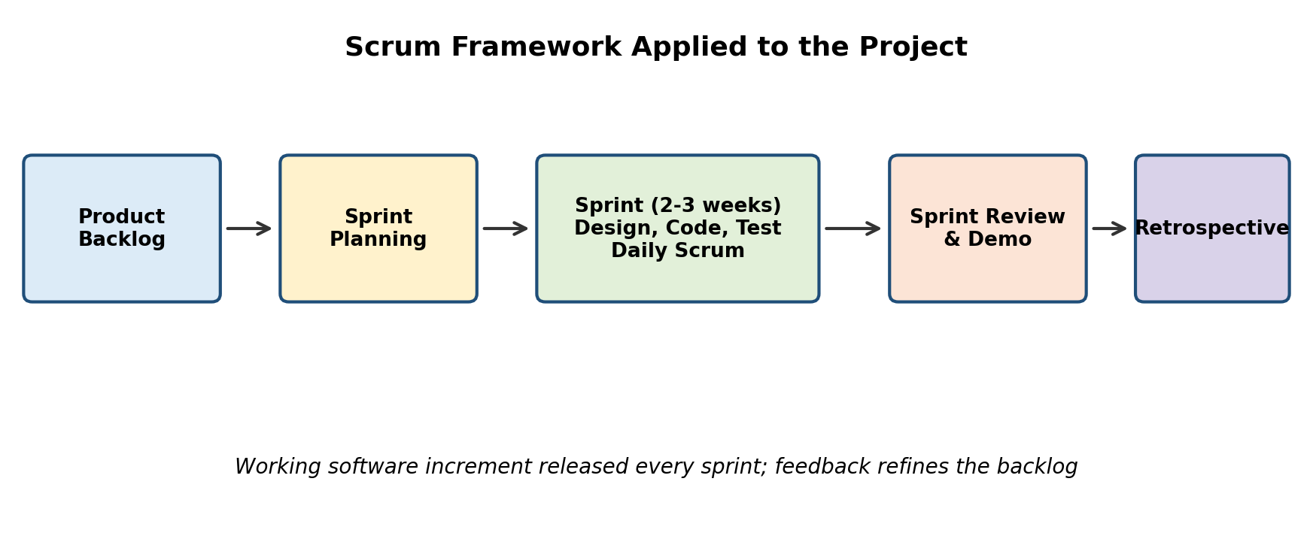
Figure 3: Scrum framework applied to the project

5.2 Justification
- Evolving requirements: stakeholders (managers, technicians, analysts) will refine needs as they see the system, which Agile handles through backlog re-prioritization.
- Early value: core modules like inventory and maintenance tracking can be released early and used while later modules are developed.
- Integration risk: connecting different equipment and data sources is uncertain; short iterations expose problems early.
- Continuous feedback: sprint reviews with plant managers and technicians improve usability and acceptance.
- Why not Waterfall: it assumes all requirements are fixed upfront and delivers only at the end, which is risky for a data-integration-heavy system.
- Quality and speed: continuous integration, automated testing and DevOps practices can be combined with Scrum for reliable frequent releases.

5.3 Support for Project Development and Maintenance
Scrum roles (Product Owner, Scrum Master, Development Team), the product backlog, daily stand-ups, sprint reviews and retrospectives give transparency and control over progress, cost and risk. Because the product is built incrementally with automated tests and version control, new asset types, sensors and reports can be added in later sprints, so the same process supports long-term maintenance and enhancement after deployment.

6. Discuss Expected Outcomes and Limitations

6.1 Expected Benefits
- Improved renewable asset utilization and energy yield.
- Reduced equipment downtime through early fault detection.
- Better preventive maintenance and fewer emergency repairs.
- Improved operational visibility across all sites.
- Faster fault response and resolution.
- Extended asset life and more effective asset management.
- Faster, more accurate reporting and easier regulatory compliance.

6.2 How the Solution Addresses the Identified Challenges
Challenge | How the Solution Addresses It
Scattered data | Centralized asset database and history.
Reactive maintenance | Threshold alerts and trend analysis enable proactive action.
Missed schedules | Automated maintenance scheduler with reminders and work-order tracking.
Remote, distributed sites | Remote monitoring dashboards and mobile access.
Heterogeneous equipment | Integration layer with standard protocols and APIs.
Poor traceability | Complete fault, repair and maintenance history per asset.
Reporting effort | Automated operational reports in PDF/Excel.

6.3 Potential Risks, Implementation Challenges and Limitations
- Data integration: legacy or proprietary equipment may not expose data easily.
- Data quality: faulty sensors or missing readings can cause false alerts.
- User adoption: staff accustomed to manual methods may resist change; training is required.
- Connectivity: poor network at remote sites can delay data.
- Security risks: connected devices increase the attack surface.
- Cost and scope creep: hardware, hosting and customization may exceed the budget if scope is not controlled.
- Limitations: the system supports decisions but does not control equipment; prediction accuracy depends on the quantity and quality of historical data.

6.4 Possible Future Enhancements
- Machine-learning based predictive maintenance and failure forecasting.
- Drone and image-based inspection of panels and blades.
- Integration with weather forecasting for generation prediction.
- Mobile app with offline mode and QR/NFC asset tagging.
- Digital twin of assets for simulation and optimization.
- Integration with ERP, inventory and energy-trading systems.
- Carbon-savings and sustainability reporting.

Conclusion
The Smart Renewable Energy Asset Management System replaces scattered, reactive manual practices with a centralized, data-driven platform. Designed with modular, scalable, secure architecture and developed through Scrum, it helps organizations raise asset utilization, cut downtime and manage renewable assets more effectively over their life cycle.

